Physical Fitness

1. Definition
- “Ability to respond to routine physical demands,
with enough energy to cope with a sudden challenge”

- Components:
Flexibility, cardiovascular fitness, muscular fitness, body composition

- Conditioning (training): gradual enhancement of fitness components

- All components are reversible

Flexibility
- Ability to go through the complete range of motion that joints allow, in a comfortable, fluid fashion
- Influenced by
- Individual differences
- Gender
- Fatness/muscularity
- Age: flexibility ↑ until adolescence than ↓
- Types of stretching
- Ballistic (unsafe): rapid jerking movements (can tear muscles)
- Static (safe): moving gradually into a stretch & holding for a short time

Cardiovascular fitness
- Ability of the heart to pump blood efficiently
- Achieved through aerobic exercise
activity in which the O2 amount taken into body ≥ amount used by body
anaerobic: O2 intake insufficient → deficit made up for later (e.g. sprinting)
- Target heart rate: appropriate rate during exercise for heart/lung benefit
- Represents 60% (beginners) to 85% (advanced) of max heart rate
- Max heart rate: .♂: 220 - age (beats per minutes)
.♀: 225 - age
- Examples
- Walking (advantage over jogging: less impact & risk of injury)
- Jogging, cycling
- Swimming (little effect on bone building because no gravity)
- Cross-country skiing, skipping rope, aerobic dancing, stair-climbing, step training, rollerblading

Muscular fitness

2 components

- Strength: maximum weight one can lift/push/press in one effort
- Endurance: ability to keep lifting/pushing/pressing
- Developing muscles by demanding more of them than usual (overloading)

Benefits of muscle workouts
- Enable muscles to work efficiently
- Develop muscles and make them firmer
- Improve blood circulation in muscles
- Build muscles (best calorie-burning tissue even at rest) → ↓ body fat

Types of muscle workouts
- Isometric: pushing/pulling against immovable object, holding, repeating
- Isotonic: moving loads several time (free weights or machines)
strength: high resistance, low number of repetitions
endurance: lower resistance and frequent repetitions
- Isokinetic: use of machines that overload muscles through entire motion
(highly effective for strength)

Proper muscle workout should exercise all body’s primary muscle groups
- Deltoids (shoulders)
- Pectorals (chest)
- Triceps and biceps ( back & front of upper arms)
- Quadriceps & hamstrings (front & back of thighs)
- Gluteus maximus (buttocks)
- Abdominals
- Dorsal

Use of steroids
- Synthetic derivatives of male hormone, used in dangerous forms/doses
- Have side effects on reproductive organs, mind & blood cholesterol

Body composition

Lean:fat ratio

Achieved through regular exercise and good nutrition

Total fitness
Requires cross-training: combination of different fitness activities
2. Benefits of Exercise
Mood
- Increased alertness & concentration
- Improved handling of stress
- Reduced anxiety & risk of depression

Cardiovascular system
- Heart: more efficient blood pumping
- Blood pressure: helps lower blood pressure
- Vascular Diseases
↓ bad cholesterol & ↑ good => ↓ risk of atherosclerosis (fat deposit)
enhances clot-dissolving substances in the blood

Lungs
Increased vital lung capacity (max air that can be inhaled/exhaled)

Bones
- Thicker bones
- Slower calcium loss with age => prevents osteoporosis

Digestion improvement

Cancer prevention (especially in digestive tract)

Diabetes (type II): increases insulin sensitivity

Reduced menstrual cramps
Weight: reduces body fat
- Burns off calories during exercise
- Metabolism remains high up to 12 hours after exercise
- Builds muscle mass: great calorie-burning tissue even at rest

More active old age (strength & mobility)
Slows down the changes associated with age, which are:
↓ lean tissue & ↑ in body fat
↓ in work capacity

Extended life span

3. Intensity of exercise
- Light: ↑ O2 consumption → less than 3x the level used at rest

- Moderate: ↑ O2 consumption → 3x to 6x the level used at rest

- Vigorous: ↑ O2 consumption → more than 6x the level used at rest

4. Amount of training needed (according to type)
- Flexibility: at least 4 reps/major muscle group; 2-3x/week

- Cardiovascular fitness: 20 – 60 min; 3-5x/week

- Muscular fitness: sets of 8-15 reps/major muscle group; 2-3x/week
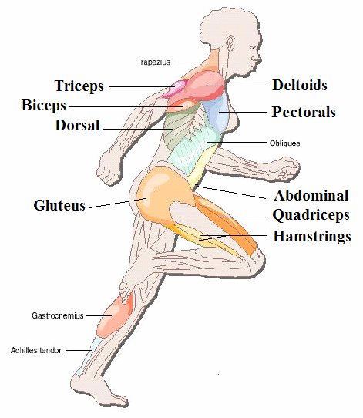

5. Making the Commitment
- Importance of starting young (building up interest for physical activity)

- Choosing a sport one enjoys & going with a buddy

- Possible obstacles
- Lack of time, scheduling difficulties
- Lack of discipline
- Dislike of effort
- Injuries or other physical limitations
- Lack of affordable, accessible places to exercise
- Lack of skills or confidence in one’s ability
- Women (in particular)
family matters
misconceptions: fear to bulk up their muscles

- Situations that require medical advice before starting
- Known heart problems or family history
- High blood pressure
- Pain in left chest, neck, shoulder or arm during/right after exercise
- Feeling dizzy/faint after mild exertion (e.g. short walk at moderate pace)
- Bone or joint problems
- Diabetes
- Sedentary above 40 years of age

6. Nutrition for Exercise

- High in CHO
- At least 60% of total cal
- Provide enough glycogen & steady blood glc

- Proteins
- No significant increase required
- Excess → burden on liver & kidneys

- Fats: kept low

- Water
- Before, during and after exercise
- Best beverage for dehydration (easier absorption than any athletic drink)

- Fruits and vegetables: large amounts
- Low in fat, supply CHO
- High in water
- Supply antioxidants:
neutralize cell damaging free radicals
free radical production ↑ by exercise due to ↑ cell metabolism

- Supplements
- Amino acids, salt tablets, energy bars & drinks, creatine …
- To be avoided: risk of nutritional imbalance or useless

7. Sports Safety

Injuries
- Types
- Acute: sudden trauma → bruises, pulled muscles
stress fracture
muscle strain
tendinitis
- Overuse: result of overdoing →

- Prevention
- Starting slowly than increasing gradually
- Never overworking muscles
- Being vigilant about any ache, pain…
- Using protections when required (helmet, knee & elbow pads)

Over-training
- Pushing to intensely / frequently

- Signs
- Muscle soreness
- Difficulty to recover after workout
- Inability to relax, nervousness
- Frequent injuries

- Reduce or stop temporarily

- Re-increase gradually with professional supervision

Temperature

- Heat
- Light colored clothes
- Preferred material: cotton: absorbs perspiration
- No impermeable materials: don’t dissipate heat & sweat
- Drinking plenty of water

- Cold
- Dark colored clothes
- Covered as much as needed but not overdressed
one layer less than if not exercising
if very low temperature: cover head, neck & hands
- No impermeable material

Pollution

Avoiding outdoor exercise on smoggy days, especially around noon:
fumes + sunlight = ozone → lung irritation & bronchi narrowing

Clothing
- According to weather
- Always loose-fitting (free movements, good blood circulation)

Shoes
- Change with miles
- Shop late in afternoon when feet are swollen
- Choose according to type of activity
- Light weight, material that breathes

8. Choosing Fitness Products & Programs
- Equipment
- Asking for professional recommendations
- Always trying (5 – 10 min) before buying

- Clubs
- Have facilities for complete workouts
- Close to home, work, campus
- Open at convenient hours
- Visiting
at times of probable use (check if crowded)
to observe classes (personalized attention from instructors)

